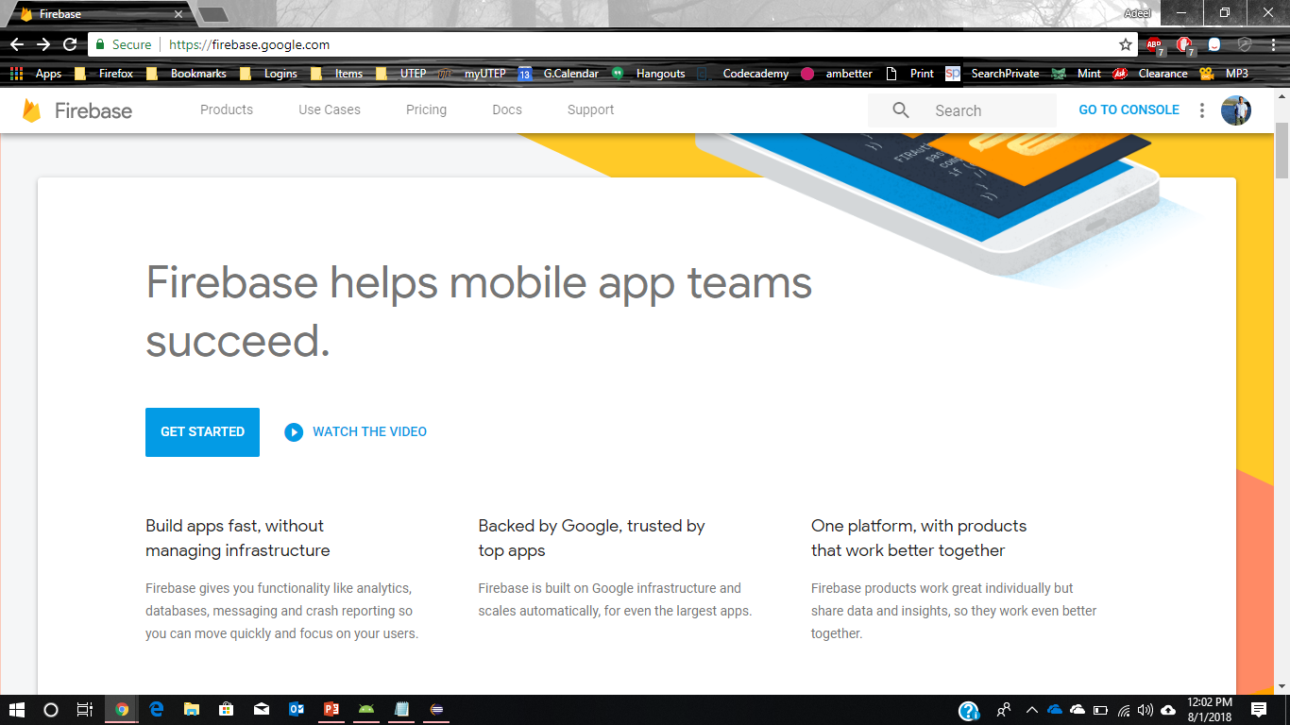

edu.utep.cs.cs4330.fitnesstracker

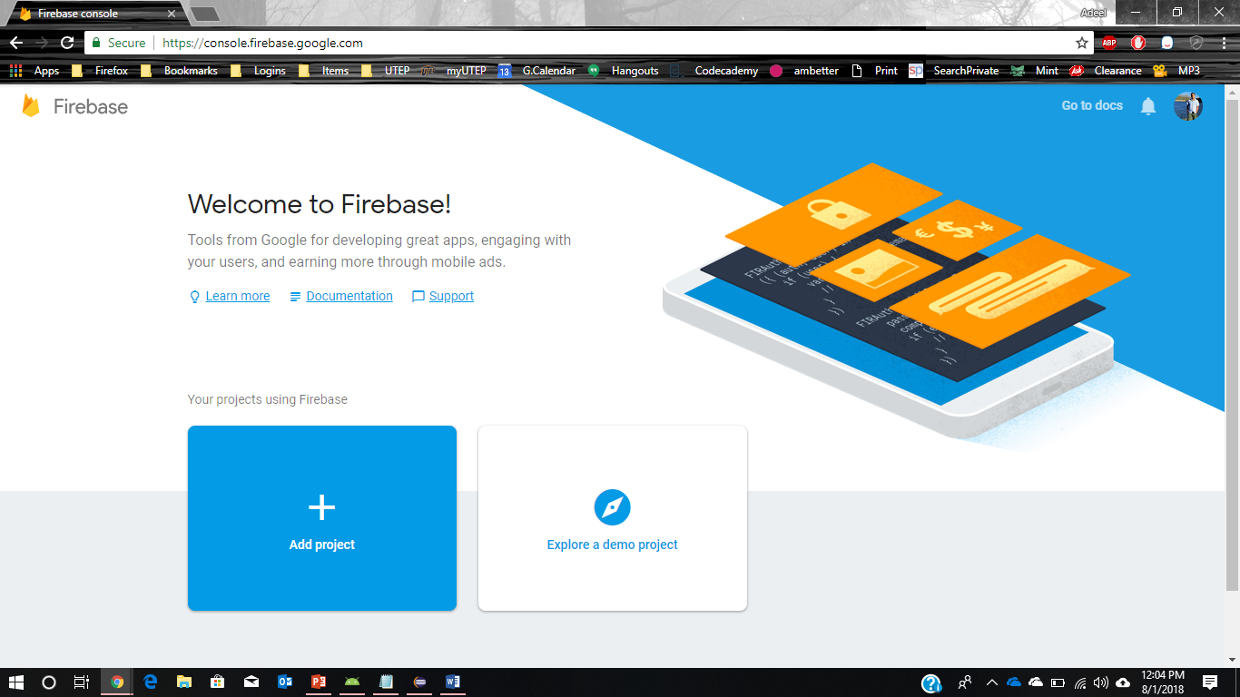

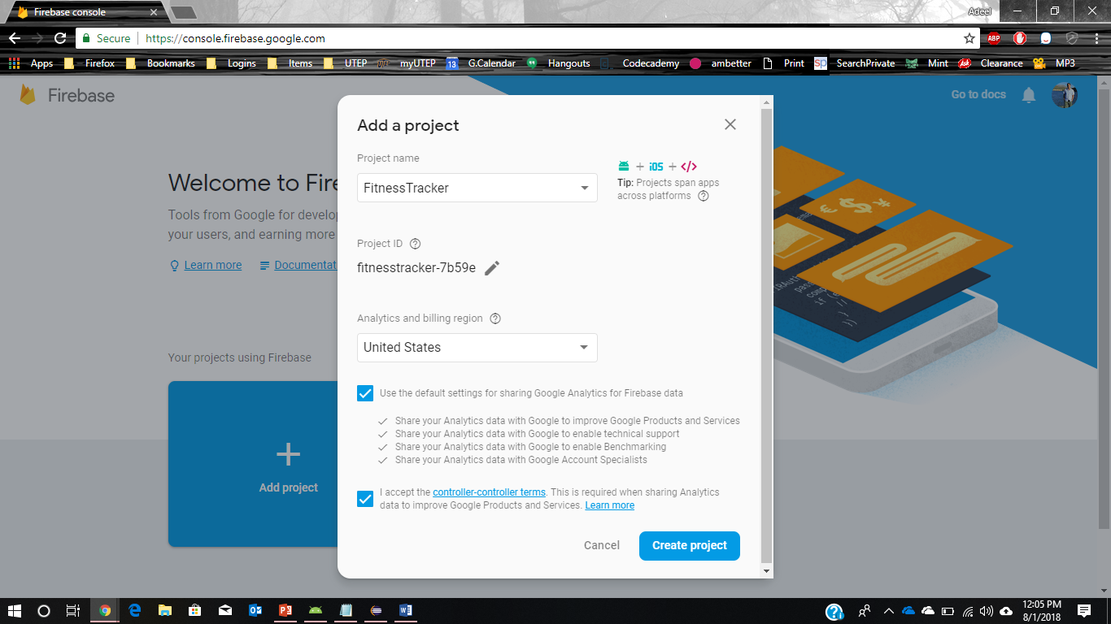

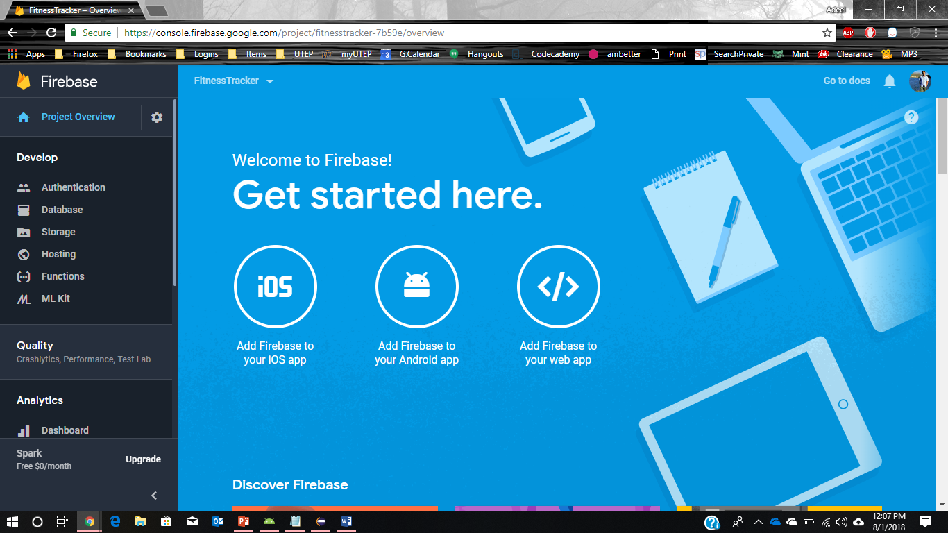

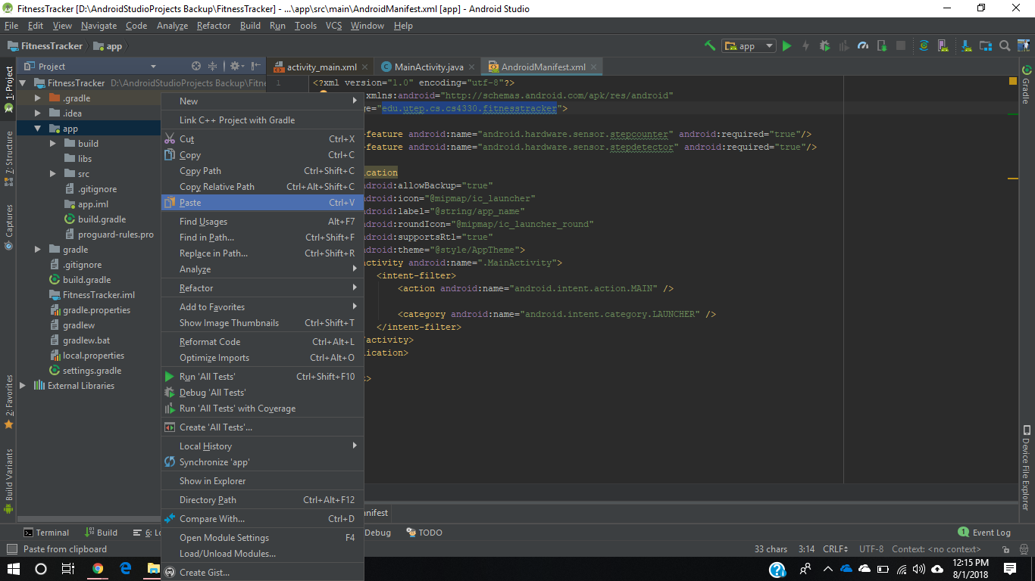

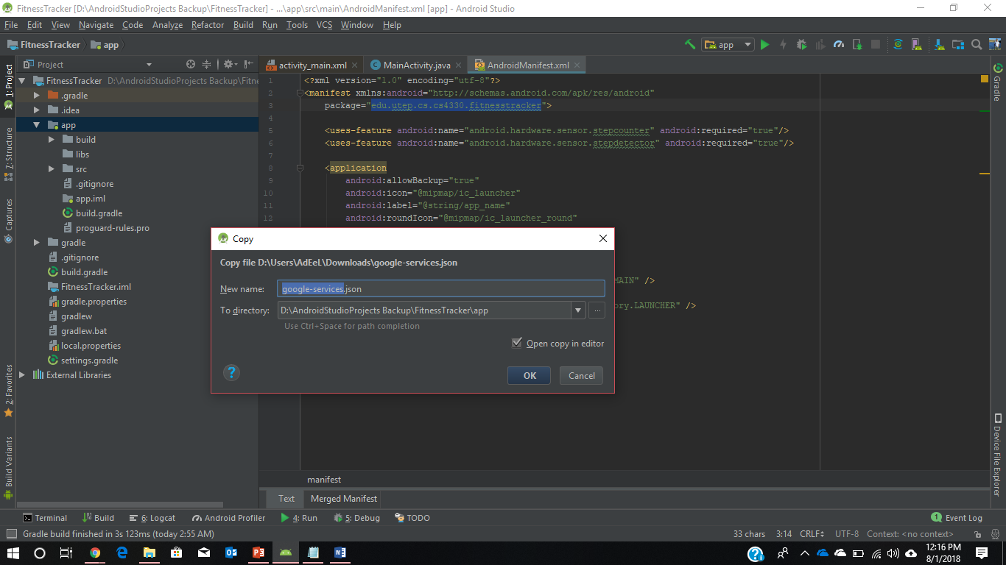

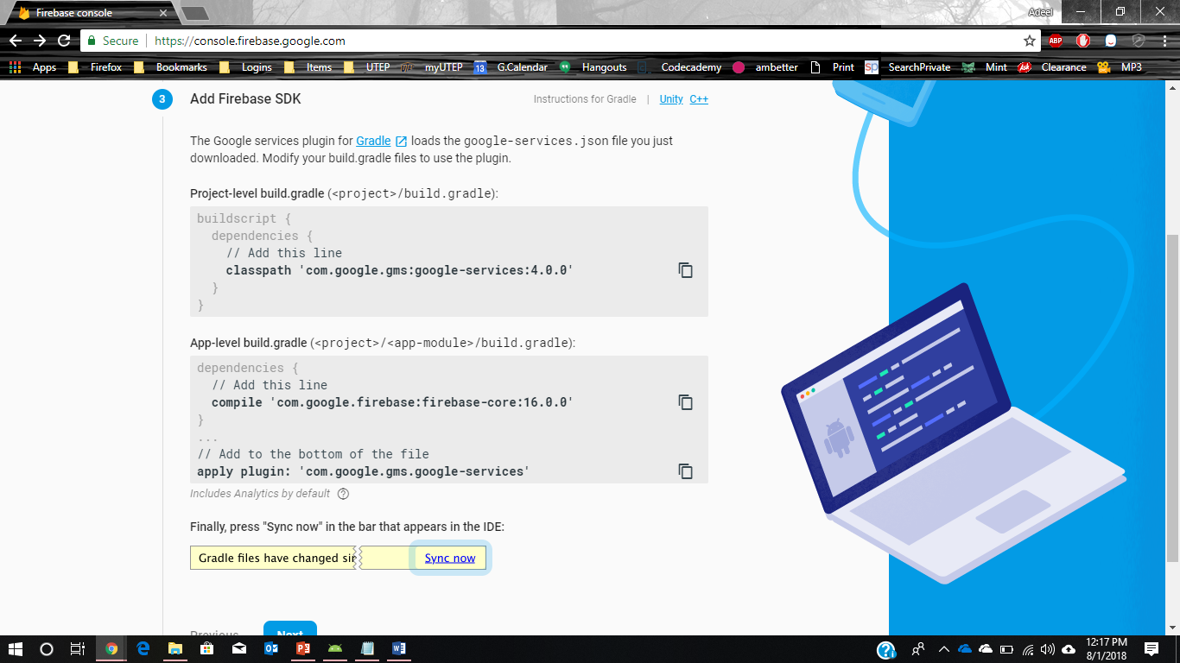

Change

compile **'com.google.firebase:firebase-core:16.0.0'**

With

implementation **'com.google.firebase:firebase-core:16.0.0'**

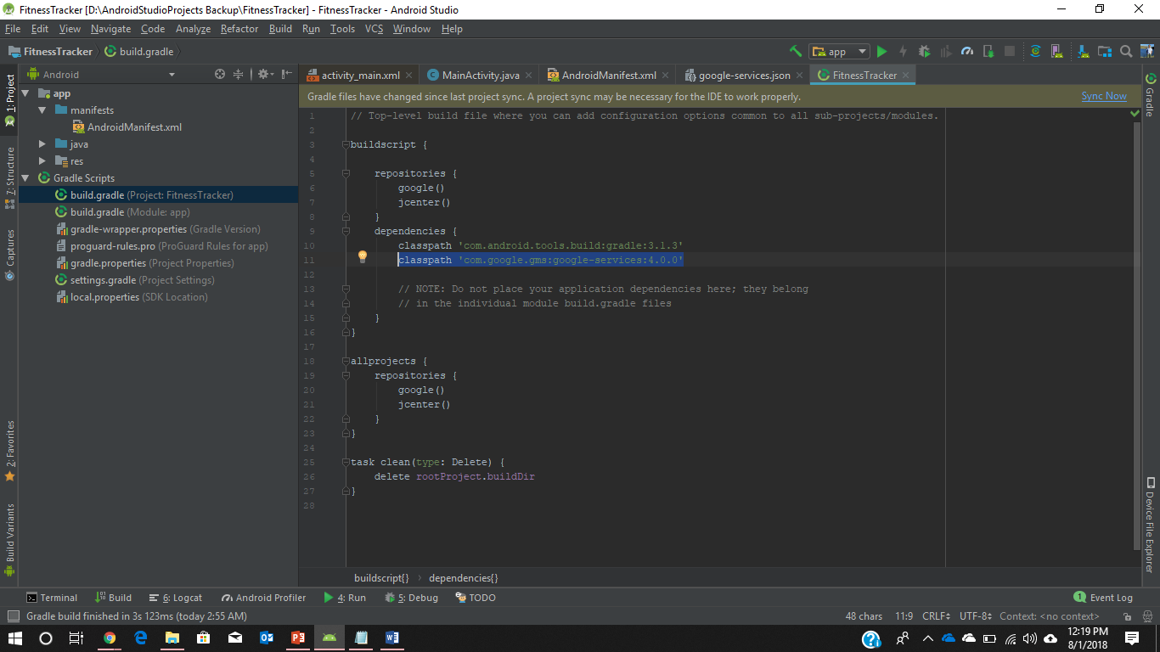

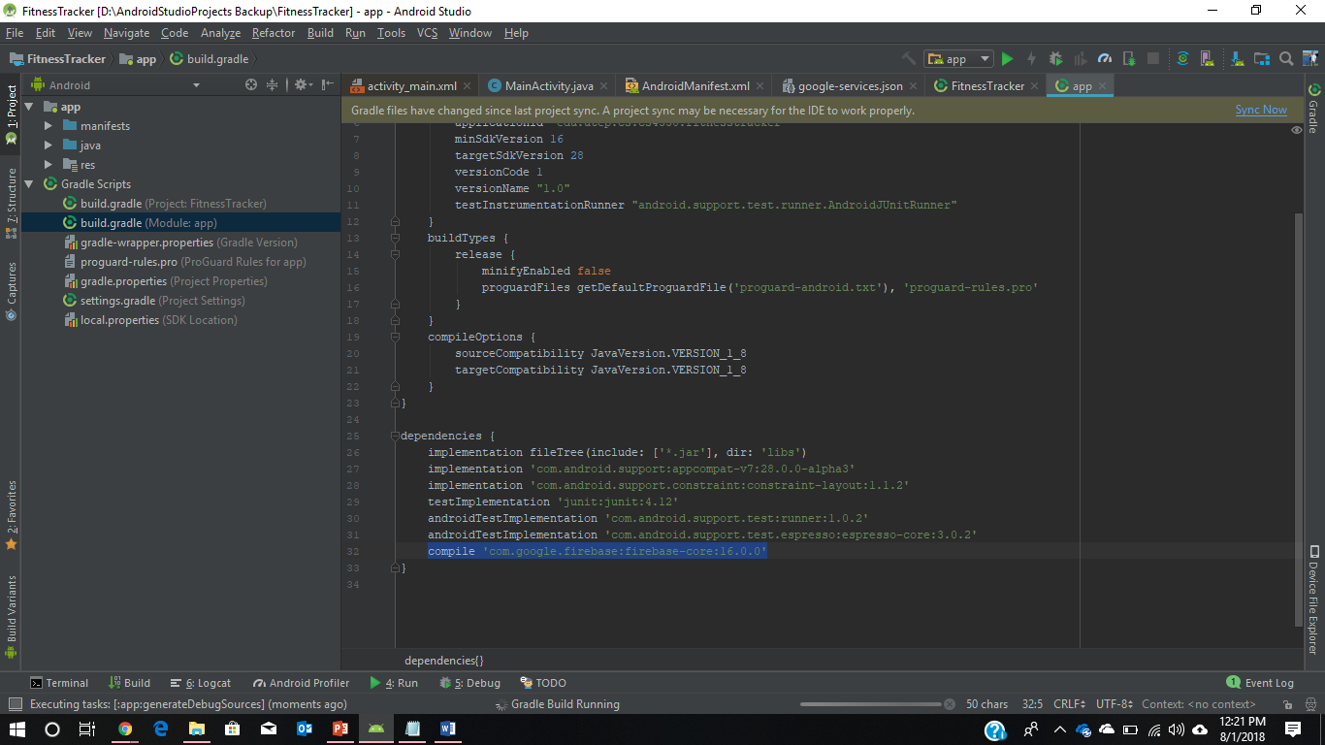

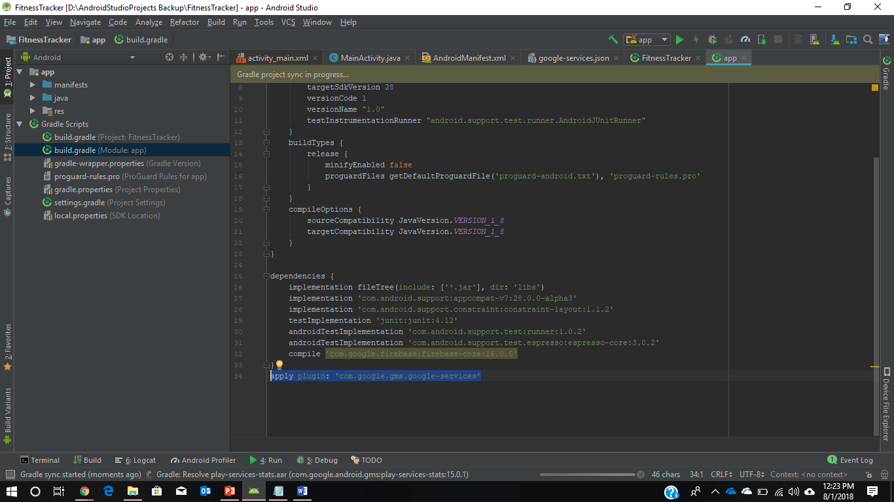

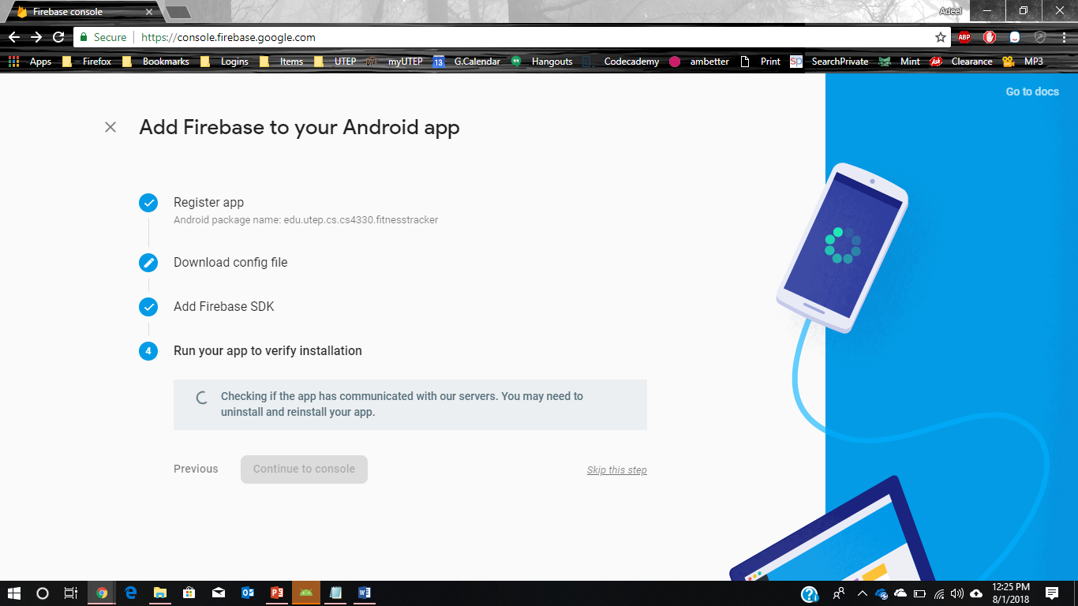

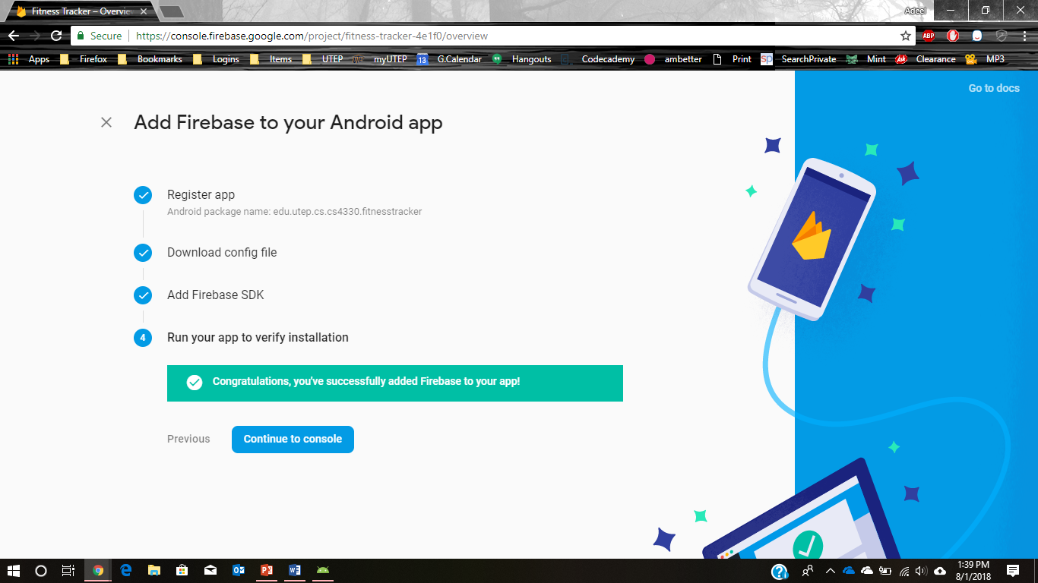

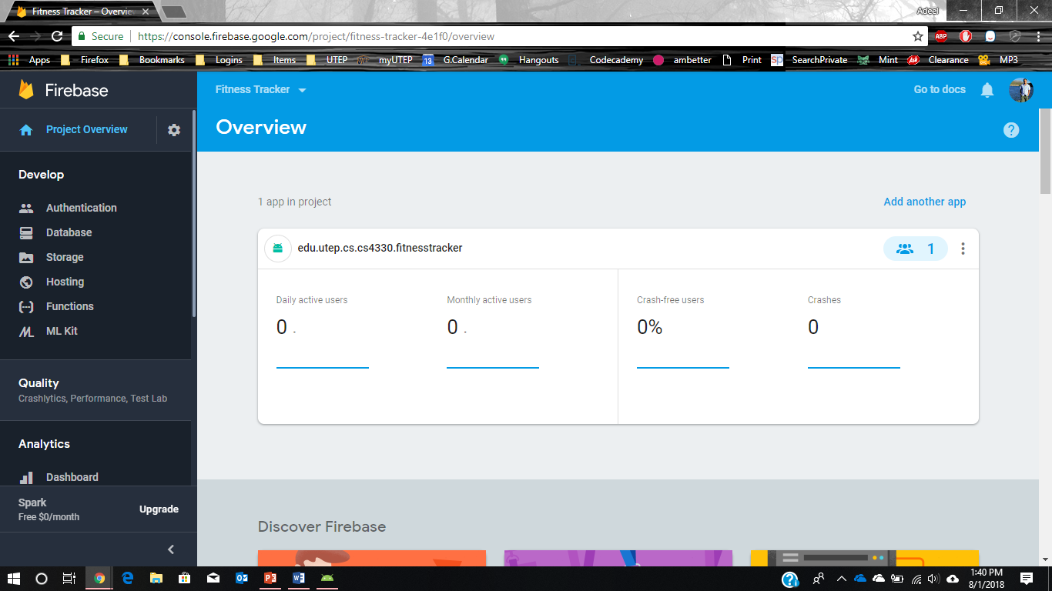

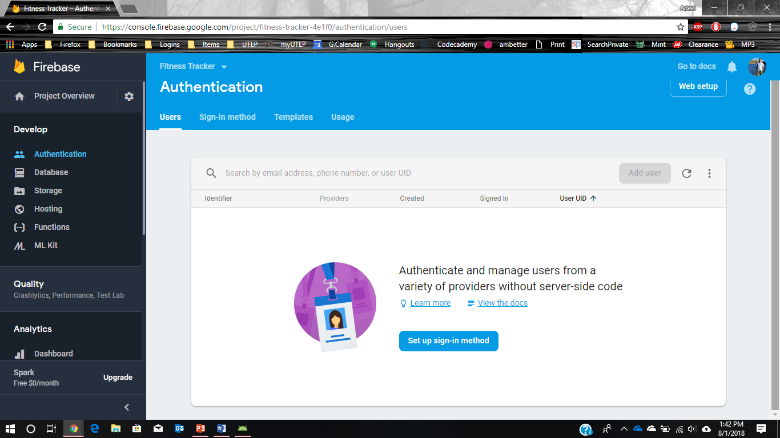

Issues

Issue 1:

Change

compile **'com.google.firebase:firebase-core:16.0.0'**

With

implementation **'com.google.firebase:firebase-core:16.0.0'**

Issue 2: how to enable Identity Toolkit API has not been used in firebase

Use the following link

<https://console.developers.google.com/apis/library/identitytoolkit.googleapis.com/?project=>

Issue 3: If you do not add the logout code, your app remains logged in on firebase, even if you close and open the app again.

Issue 4: “class file for com.google.android.gms.internal.zzeuq not found” dependencies issue.

Issue 5: database rule – after setup, database rule setup required, basically access levels, in my case, I have allowed anyone to read and write.

// These rules allow anyone read or write access to your database  
{  
  "rules": {  
    ".read": true,  
    ".write": true  
  }  
}

On the database console, switch to Realtime database .

More details can be found on <https://firebase.google.com/docs/database/security/>

<https://angularfirebase.com/lessons/understanding-firebase-database-rules-by-example/>

Item Added:

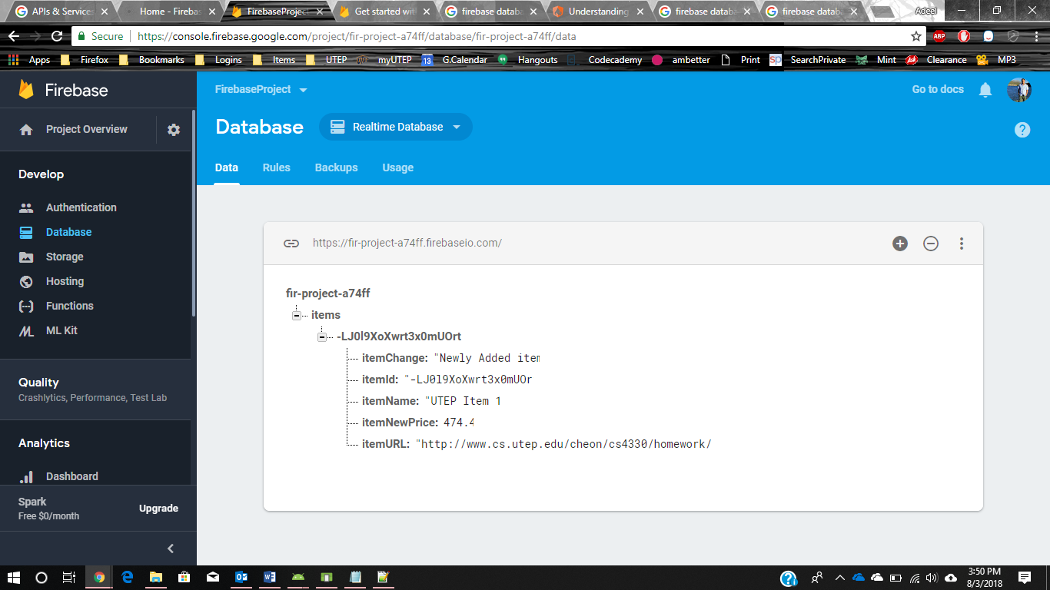

Issue 6:

Consoles

For APIs:

https://console.developers.google.com/apis/dashboard?project=fir-project-a74ff

Google Cloud Platform:

https://console.cloud.google.com/home?project=fir-project-a74ff

Firebase:

https://console.firebase.google.com/project/fir-project-a74ff/

Issue 7: after creating a project, do not delete it to create a new one, deleting and creating new ones, there is a limit to it.

Homework 3 SQLite Database (itemsDB)

|  |  |
| --- | --- |
| ID | AutoIncrement (Primary Key) |
| ItemName | String |
| URL | String |
| Price | REAL |
| Change | String |

Table (items)

|  |  |  |  |  |
| --- | --- | --- | --- | --- |
| ID | ItemName | URL | Price | Change |
| 1 | UTEP Test Item | http://www.cs.utep.edu/cheon/cs4330/homework/hw3/ | 303.17 | Price dropped 30% |
| 2 | Amazon Item | https://www.amazon.com/dp/B07D4F2P26/ref_=fs_ods_fs_smp_re | 329.99 | Newly Added Item |
| 3 | Walmart Item | https://www.walmart.com/ip/Casio-Men-s-Twin-Sensor-Compass-Watch-Black | 46.52 | Newly Added item |

Firebase stores the same data in JSON tree structure instead of tabular format.

{

Items:{

Item_id_1:{

ItemName: "UTEP Test Item "

URL: "http://www.cs.utep.edu/cheon/cs4330/homework/hw3/"

Price: 303.17

Change: "Price dropped 30%"

},

Item_id_2:{

ItemName: " Amazon Item "

URL: " https://www.amazon.com/dp/B07D4F2P26/ref_=fs_ods_fs_smp_re "

Price: 329.99

Change: " Newly Added Item "

},

Item_id_3:{

ItemName: "Walmart Item "

URL: " https://www.walmart.com/ip/Casio-Men-s-Twin-Sensor-Compass-Watch-Black "

Price: 46.52

Change: "Newly Added item "

}

}

}

Two types of operations – authenticated users read/write to db and anyone can read/write to db. Since we are authenticating at login screen, we do not need to authenticate again to reduce complexity.